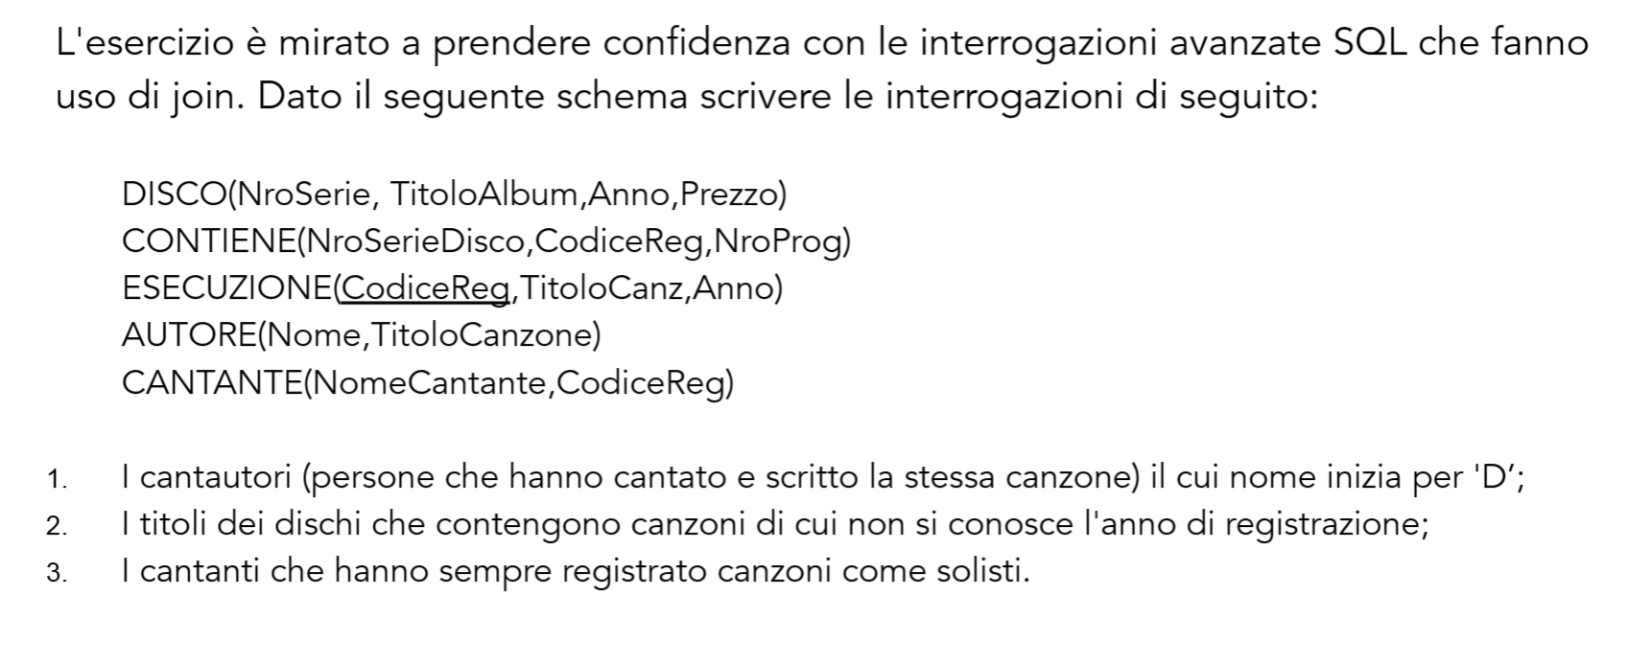

1)

SELECT a.TitoloCanzone

From Autore AS a

Join Cantante AS c

ON a.Nome = c.NomeCantante

WHERE a.NomeCantante LIKE ‘D%’

2)

SELECT \* FROM Disco

SELECT \* FROM Esecuzione

SELECT \* FROM Contiene

SELECT d.TitoloAlbum AS TitoloAlbum

, e.TitoloCanz AS TitoloBrano

, e.Anno AS AnnoBrano

FROM Disco AS d

INNER JOIN Contiene AS c

ON d.NmrSerie = c.NmrSerieDisco

INNER JOIN Esecuzione AS e

ON e.CodiceReg = c.CodiceReg

WHERE e.Anno is null

3)

- Forse CodiceReg in Cantante non è univoco, facendo join con Esecuzione troviamo chi ha registrato insieme

Select

From Cantante

Group By NomeCantante, CodiceReg

(CREATE TABLE Cantante (Nome varchar(25),CodiceReg int)INSERT INTO CantanteVALUES ('Marco', 100), ('GianMarco', 100), ('Ida', 100), ('Ida', 200), ('Luca', 300)CREATE TABLE Esecuzione (CodiceReg int,TitoloCanz varchar(25),Anno int)INSERT INTO Esecuzione VALUES (100, '21Guns', 2009), (300, 'Niente', 2023), (200, 'Violator', 1990))

Query innestata

Select

From Cantante c

Left Join Esecuzione e

ON c.CodiceReg = e.CodiceReg

-Select CodiceReg, Count(Nome)

From Cantante

Group By Codice Reg

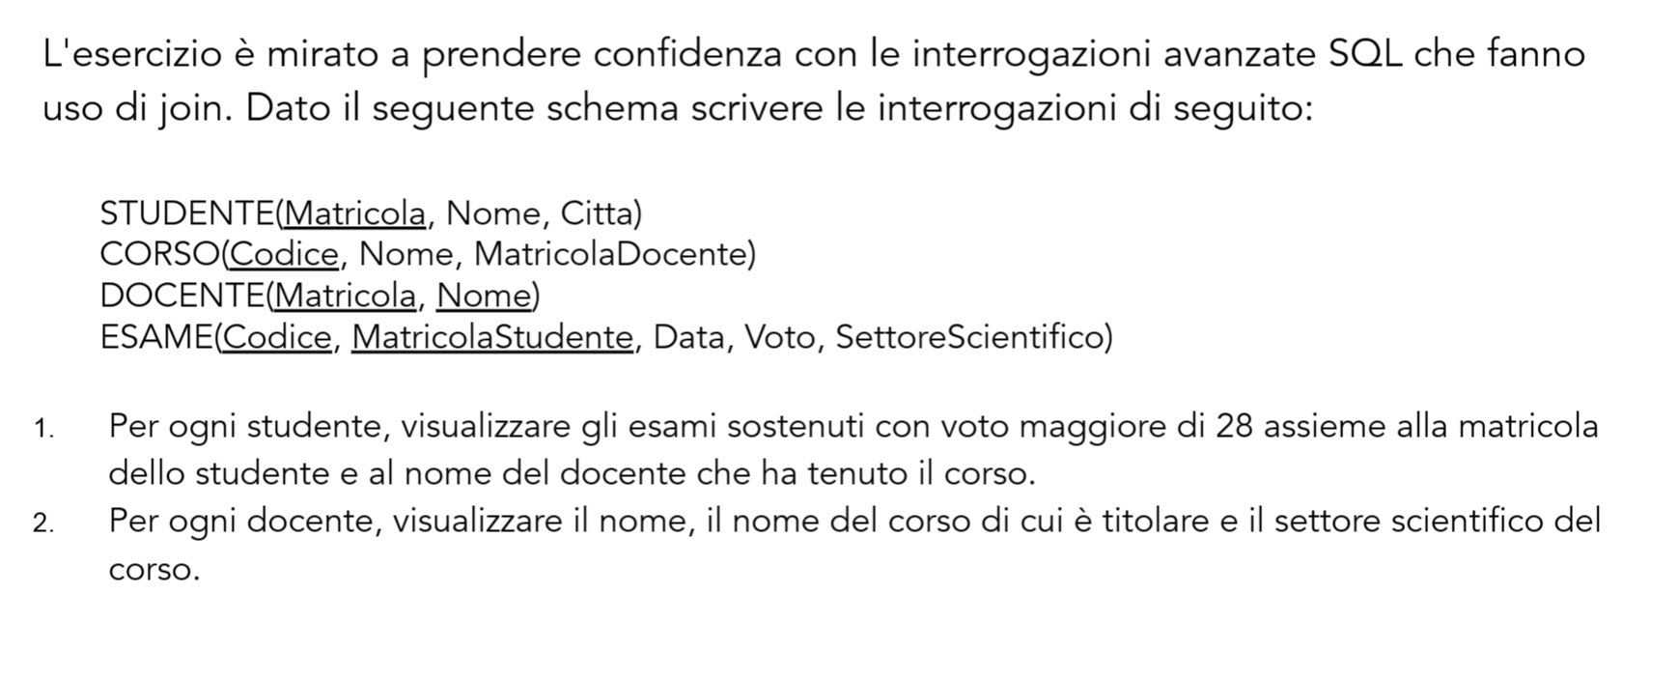

1)

SELECT e.Voto, e.MatricolaStudente, d.Nome

FROM Esame AS e

INNER JOIN Corso AS c

ON e.Codice = c.Codice

INNER JOIN Docente AS d

ON c.MatricolaDocente = d.Matricola

WHERE e.Voto > 28

2)

SELECT d.Nome, c.Nome, e.SettoreScientifico

FROM Docente AS d

INNER JOIN Corso AS c

ON d.Matricola = c.MatricolaDocente

INNER JOIN Esame AS e

ON c.Codice = e.Codice

-- Utilizzate AdventureWorksDW2022-- Esercizio 4 -- Denormalizzare l'entità Prodotto (DimProduct, DimProductSubcategory, DimProductCategory)-- Esercizio 5 -- Denormalizzare l'entità Reseller (DimReseller, DimGeography)-- Esercizio 6 (Union) -- Accodare i record della tabella FactresellerSales, FactinternetSales

Denormalizzare = unico result set

New Database Diagrams

Tsato dx proprietà (sulla linea relazione)

Select \*

From DimProduct

Selezione dx query designer

Dx add tables

Esercizio 4

SELECT

FROM DimProduct AS Product

FULL OTHER JOIN DimProductSubcategory AS Subcategory

ON Product.ProductSubcategoryKey = Subcategory.ProductSubcategoryKey

FULL OTHER JOIN DimProductCategory AS Category

ON Subcategory.ProductCategoryKey AS Category.ProductCategoryKey

SELECT \*

FROM DimProduct

SELECT \*

FROM DimProductSubcategory

SELECT \*

FROM DimProductCategory

SELECT DimProduct.ProductKey, DimProduct.ProductAlternateKey, DimProduct.ProductSubcategoryKey, DimProduct.WeightUnitMeasureCode, DimProduct.SizeUnitMeasureCode, DimProduct.EnglishProductName,

DimProduct.SpanishProductName, DimProduct.FrenchProductName, DimProduct.StandardCost, DimProduct.FinishedGoodsFlag, DimProduct.Color, DimProduct.SafetyStockLevel, DimProduct.ReorderPoint, DimProduct.ListPrice,

DimProduct.Size, DimProduct.SizeRange, DimProduct.Weight, DimProduct.DaysToManufacture, DimProduct.ProductLine, DimProduct.DealerPrice, DimProduct.Class, DimProduct.Style, DimProduct.ModelName, DimProduct.LargePhoto,

DimProduct.EnglishDescription, DimProduct.FrenchDescription, DimProduct.ChineseDescription, DimProduct.ArabicDescription, DimProduct.HebrewDescription, DimProduct.ThaiDescription, DimProduct.GermanDescription,

DimProduct.JapaneseDescription, DimProduct.TurkishDescription, DimProduct.StartDate, DimProduct.EndDate, DimProduct.Status

FROM DimProduct

INNER JOIN DimProductSubcategory

ON DimProduct.ProductSubcategoryKey = DimProductSubcategory.ProductSubcategoryKey

INNER JOIN DimProductCategory

ON DimProductSubcategory.ProductCategoryKey = DimProductCategory.ProductCategoryKey

/\* Esercizio 4

\*/

SELECT DimProduct.ProductKey, DimProduct.ProductAlternateKey, DimProduct.WeightUnitMeasureCode, DimProduct.SizeUnitMeasureCode, DimProduct.EnglishProductName,

DimProduct.SpanishProductName, DimProduct.FrenchProductName, DimProduct.StandardCost, DimProduct.FinishedGoodsFlag, DimProduct.Color, DimProduct.SafetyStockLevel, DimProduct.ReorderPoint, DimProduct.ListPrice,

DimProduct.Size, DimProduct.SizeRange, DimProduct.Weight, DimProduct.DaysToManufacture, DimProduct.ProductLine, DimProduct.DealerPrice, DimProduct.Class, DimProduct.Style, DimProduct.ModelName, DimProduct.LargePhoto,

DimProduct.EnglishDescription, DimProduct.FrenchDescription, DimProduct.ChineseDescription, DimProduct.ArabicDescription, DimProduct.HebrewDescription, DimProduct.ThaiDescription, DimProduct.GermanDescription,

DimProduct.JapaneseDescription, DimProduct.TurkishDescription, DimProduct.StartDate, DimProduct.EndDate, DimProduct.Status,

DimProductSubcategory.ProductSubcategoryKey, DimProductSubcategory.ProductSubcategoryAlternateKey, DimProductSubcategory.EnglishProductSubcategoryName, DimProductSubcategory.SpanishProductSubcategoryName,

DimProductSubcategory.FrenchProductSubcategoryName,

DimProductCategory.ProductCategoryKey, DimProductCategory.ProductCategoryAlternateKey, DimProductCategory.EnglishProductCategoryName, DimProductCategory.SpanishProductCategoryName,

DimProductCategory.FrenchProductCategoryName

FROM DimProduct

FULL OUTER JOIN DimProductSubcategory

ON DimProduct.ProductSubcategoryKey = DimProductSubcategory.ProductSubcategoryKey

FULL OUTER JOIN DimProductCategory

ON DimProductSubcategory.ProductCategoryKey = DimProductCategory.ProductCategoryKey

/\* Esercizio 5

\*/

SELECT \*

FROM DimReseller

SELECT \*

FROM DimGeography

SELECT \*

FROM DimSalesTerritory

SELECT DimReseller.ResellerKey, DimReseller.ResellerAlternateKey, DimReseller.Phone, DimReseller.BusinessType, DimReseller.ResellerName, DimReseller.NumberEmployees, DimReseller.OrderFrequency,

DimReseller.OrderMonth, DimReseller.FirstOrderYear, DimReseller.LastOrderYear, DimReseller.ProductLine, DimReseller.AddressLine1, DimReseller.AddressLine2, DimReseller.AnnualSales, DimReseller.BankName,

DimReseller.MinPaymentType, DimReseller.MinPaymentAmount, DimReseller.AnnualRevenue, DimReseller.YearOpened,

DimGeography.GeographyKey, DimGeography.City, DimGeography.StateProvinceCode, DimGeography.StateProvinceName, DimGeography.CountryRegionCode, DimGeography.EnglishCountryRegionName,

DimGeography.SpanishCountryRegionName, DimGeography.FrenchCountryRegionName, DimGeography.PostalCode, DimGeography.IpAddressLocator,

DimSalesTerritory.SalesTerritoryKey, DimSalesTerritory.SalesTerritoryAlternateKey, DimSalesTerritory.SalesTerritoryRegion, DimSalesTerritory.SalesTerritoryCountry, DimSalesTerritory.SalesTerritoryGroup,

DimSalesTerritory.SalesTerritoryImage

FROM DimReseller

FULL OUTER JOIN DimGeography

ON DimReseller.GeographyKey = DimGeography.GeographyKey

FULL OUTER JOIN DimSalesTerritory

ON DimGeography.SalesTerritoryKey = DimSalesTerritory.SalesTerritoryKey

/\* Esercizio 6

\*/

SELECT \*

FROM FactResellerSales

SELECT \*

FROM FactInternetSales

SELECT ProductKey, OrderDateKey, DueDateKey, ShipDateKey, ResellerKey, EmployeeKey, PromotionKey, CurrencyKey, SalesTerritoryKey, SalesOrderNumber, SalesOrderLineNumber, RevisionNumber, OrderQuantity, UnitPrice,

ExtendedAmount, UnitPriceDiscountPct, DiscountAmount, ProductStandardCost, TotalProductCost, SalesAmount, TaxAmt, Freight, CarrierTrackingNumber, CustomerPONumber, OrderDate, DueDate, ShipDate

FROM FactResellerSales

UNION

SELECT ProductKey, OrderDateKey, DueDateKey, ShipDateKey, CustomerKey, null, PromotionKey, CurrencyKey, SalesTerritoryKey, SalesOrderNumber, SalesOrderLineNumber, RevisionNumber, OrderQuantity, UnitPrice, ExtendedAmount,

UnitPriceDiscountPct, DiscountAmount, ProductStandardCost, TotalProductCost, SalesAmount, TaxAmt, Freight, CarrierTrackingNumber, CustomerPONumber, OrderDate, DueDate, ShipDate

FROM FactInternetSales